Monitoring Sea Shipping Lanes
Alex Roan (alr16)

Introduction
This document explains my design decisions, implementation and outcome of my program.
I feel I have successfully completed the main mission and have attempted to implement the extended mission. My program reads in ‘fixed’ files, saves the boats in memory (as a linked list) and simulates their movement according to a simulation duration and step time. It produces a file called out.txt which contains log information of all the major events (Ships moving in and out of the shipping area, warnings about close contact and crashes) as well as printing information about ship positioning at each step in the standard output.

Design
From the outset I decided on creating 4 files to split up my methods for simplicity. These files are main.c, linked_list.c, simulator.c and file_handler.c.
main.c
main.c would handle the initial reading of standard input and use it to begin the simulation by passing the arguments (file to be read, duration of simulation and step time) into the run() method in the simulator file.
simulator.c
simulator.c will hold methods involving the simulation of ships moving at each step until the duration of simulation is fulfilled. Run() will loop through each minute changing the positions of all the boats in the linked list and comparing their new positions with each other.
linked_list.c
I decided that I would use a linked list to store the boats when a file is read in. Each ‘ship’ structure in the linked list would contain the name of the ship, the latitude and longitude, the direction, the speed and the next ship in the linked list. To make it easier to remove from the front the front of the list (if a boat at the head has crashed), I decided to use a ‘dummy’ node at the head.

(‘Dummy’ or head)
In the event of a boat at the front crashing, the dummy node’s next pointer would be changed to the crashed node’s next pointer like so:

The crashed node would then be freed from memory. linked_list.c holds methods relating to adding and removing from the linked list as well as displaying all of the data in it.
file_handler.c
file_handler.c contains methods which read and write files. The read file method will read in the fixed data files and the write methods are responsible for writing the out.txt log file.

Evaluation
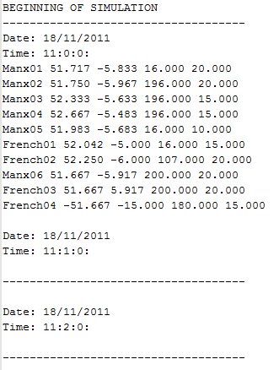
I feel that all of the specifications for the main mission have been completed successfully in my program. The program prompts for the file to be read and reads the data in. It then asks for the duration of time for the program to simulate and duration of time for each step forward. It then simulates each step for the specified duration whilst at the same time printing out any event which occurs at each step and prints the outcome to the standard input and the out.txt file. These events include if there is a risk of collision, an actual collision occurs, if a ship sails out and if a ship sails into the shipping area. Below is an example of the beginning of the out.txt file:

As you can see, the file shows the starting time and data, and all the boats in the file. Here is an example of when 2 boats are in close proximity and eventually collide:
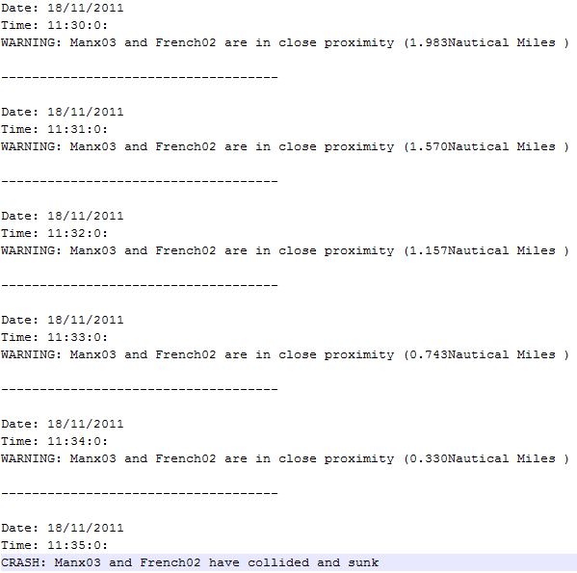

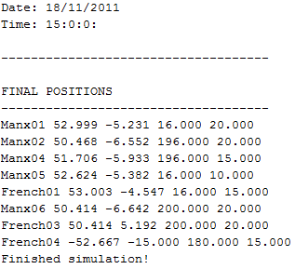
After 3 hours of simulation at 1 minute per step, here are the final positions of the ships:

As you can see all 7 of the tasks for the main mission have been completed.
If I had time to implement an extended version I would implement a second data structure which would hold the changing boat times, directions and speeds and would act as a comparative structure. Each step forward the current_time would be checked against the changing times in the second data structure until a match is found where the ship in question would change its speed and direction according to what is in the structure.

